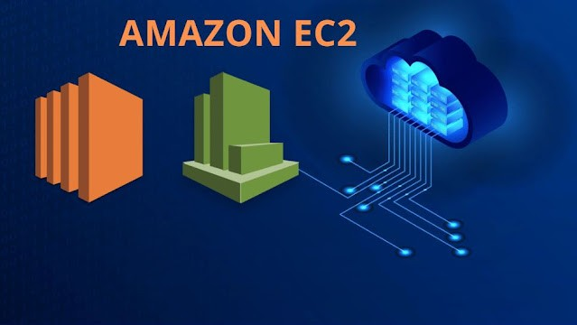

**Amazon EC2**

WHAT IS SERVER?



SERVER:

Servers are the computers that run services to serve the needs of other computers.

TYPES OF SERVERS:

Web Server : Apache, Nginx, IIS (Internet information service), GWS(Google Web server)

Application server : Apache Tomcat, F5 Nginix, IBM Websphere Database Server

Email server FTP Server File server Proxy server

Streaming server

IRC Server (Internet relay chat) Fax server

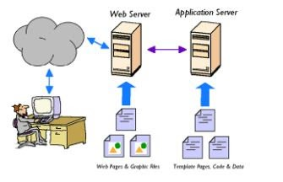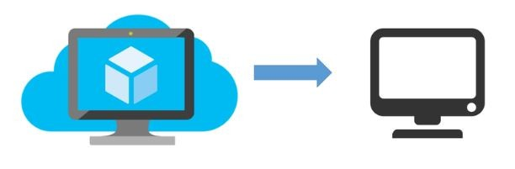

VIRTUAL MACHINE:

A VM is a program on a computer that works like it is a separate computer inside the main computer. A very powerful server can be split into several smaller virtual machines to use its resources better.

TYPES:

SYSTEM VM'S PROCESS VM'S



WHAT IS EC2?

ELASTIC COMPUTE CLOUD IS A WEB SERVICE THAT PROVIDES SECURITY AND RESIZABLE COMPUTE CAPACITY IN THE CLOUD WHICH IS DESIGNED TO USED BY DEVELOPERS EASIER.

IT IS ONE OF THE SERVICES PROVIDED BY THE AWS WHICH WE CAN USE IT TO LAUNCH INSTANCES ON DIFFERENT OS.

TO LAUCH EC2 INSTANCE THERE WILL BE SEVEN STEPS NEEDS TO BE PERFOM.

STEP-1: Choose an Amazon Machine Image (AMI):

An AMI is a template that contains the software con\guration (operating system, application server, and applications) required to launch your instance It consist of an AMI-ID which is region speci\c.

We can buy, sell and share the AMI's. We need to use free tier AMI's only

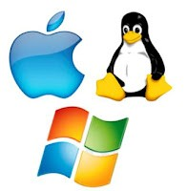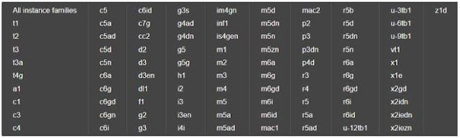

STEP-2:Choose an instance type:

In the second step, we are providing CPU & MEMORY to our instance. Here we need to select the instance type which is under free tier eligible.

T2 MICRO (1 CPU AND 1 GB) AND T2 NANO (1 CPU AND 0.5 GB)

Total instance families are 90 available

STEP-3:Con\gure your instance

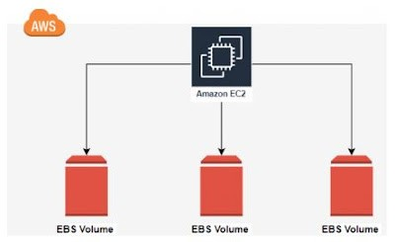

Con\gure the instance to suit your requirements. You can launch multiple instances from the same AMI, request Spot instances to take advantage of the lower pricing, assign an access management role to the instance, and more.

HERE YOU NEED TO CONFIGURE ALL YOUR INSTANCE DETAILS LIKE

NO.OF INSTANCES , SUBNETS ,VPC , IAM ROLE , TENANCY ALL OTHER STUFF

STEP-4: Add Storage

Your instance will be launched with the following storage device settings. You can attach additional EBS volumes and instance store volumes to your instance, or edit the settings of the root volume. You can also attach additional EBS volumes after launching an instance, but not instance store volumes.

Free tier eligible customers can get up to 30 GB of EBS General Purpose (SSD) or Magnetic storage.

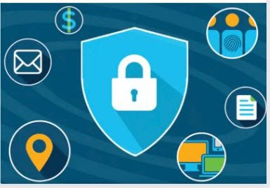

STEP-5:Add Tags

You can give a name to your instance

STEP-6:Con\gure Security Group

A security group is a set of \rewall rules that control the traec for your instance. These are region and network speci\c

The port range is 0 to 65535

It deals with the inbound and outbound traec

STEP-7:Review & Launch

